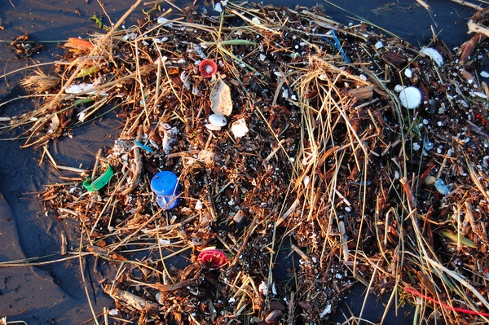 | plasticfreejuly.org  #plasticfreejuly  UK Supermarkets currently generate 900,000 tonnes of plastic packaging every year (Greenpeace)  Save plastic, get your washing-up liquid and kitchen cleaner bottles refilled (e.g. Green Weigh in Sawston or the dry cleaners in Great Shelford)  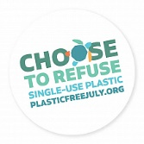
plasticfreejuly.org
#plasticfreejuly

UK Supermarkets currently generate 900,000 tonnes of plastic packaging every year (Greenpeace)

Save plastic, get your washing-up liquid and kitchen cleaner bottles refilled (e.g. Green Weigh in Sawston or the dry cleaners in Great Shelford)
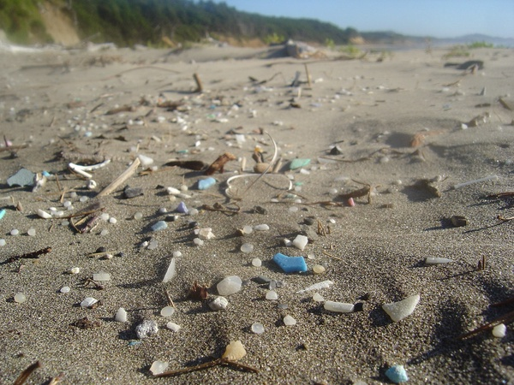 | plasticfreejuly.org  #plasticfreejuly  UK Supermarkets currently generate 900,000 tonnes of plastic packaging every year (Greenpeace)  Save plastic, get your washing-up liquid and kitchen cleaner bottles refilled (e.g. Green Weigh in Sawston or the dry cleaners in Great Shelford)
plasticfreejuly.org
#plasticfreejuly

UK Supermarkets currently generate 900,000 tonnes of plastic packaging every year (Greenpeace)

Save plastic, get your washing-up liquid and kitchen cleaner bottles refilled (e.g. Green Weigh in Sawston or the dry cleaners in Great Shelford)
plasticfreejuly.org
#plasticfreejuly

UK Supermarkets currently generate 900,000 tonnes of plastic packaging every year (Greenpeace)

Save plastic, get your washing-up liquid and kitchen cleaner bottles refilled (e.g. Green Weigh in Sawston or the dry cleaners in Great Shelford)
plasticfreejuly.org
#plasticfreejuly

UK Supermarkets currently generate 900,000 tonnes of plastic packaging every year (Greenpeace)

Save plastic, get your washing-up liquid and kitchen cleaner bottles refilled (e.g. Green Weigh in Sawston or the dry cleaners in Great Shelford)

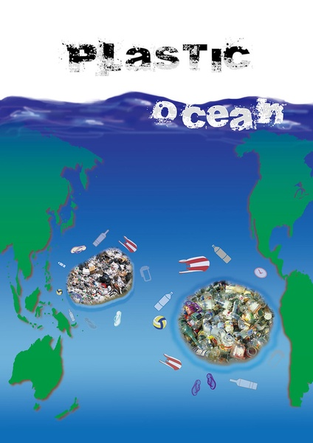 | plasticfreejuly.org  #plasticfreejuly  There is no such thing as ‘away’. When we throw anything away, it must go somewhere.  Save plastic, drink tap water. Our tap water is naturally filtered through chalk rock.  Write to your MP to ask for plastics reduction targets to be included in the Environment Bill  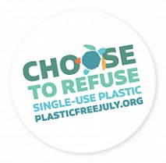
plasticfreejuly.org
#plasticfreejuly
There is no such thing as ‘away’. When we throw anything away, it must go somewhere.

Save plastic, drink tap water. Our tap water is naturally filtered through chalk rock.

Write to your MP to ask for plastics reduction targets to be included in the Environment Bill
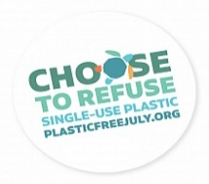
plasticfreejuly.org
#plasticfreejuly
There is no such thing as ‘away’. When we throw anything away, it must go somewhere.

Save plastic, drink tap water. Our tap water is naturally filtered through chalk rock.

Write to your MP to ask for plastics reduction targets to be included in the Environment Bill
